**Church Wealth**

***“****The Catholic Church is too wealthy, hoarding money and art instead of giving to the poor.”*

Six days before the Passover Jesus came to Bethany, the home of Lazarus, whom he had raised from the dead. There they gave a dinner for him. Martha served, and Lazarus was one of those at the table with him. Mary took a pound of costly perfume made of pure nard, anointed Jesus’ feet, and wiped them with her hair. The house was filled with the fragrance of the perfume. But Judas Iscariot, one of his disciples (the one who was about to betray him), said, “Why was this perfume not sold for three hundred denarii and the money given to the poor?” (He said this not because he cared about the poor, but because he was a thief; he kept the common purse and used to steal what was put into it.) Jesus said, “Leave her alone. She bought it so that she might keep it for the day of my burial. You always have the poor with you, but you do not always have me.” – John 12:1-8

As usual, it is important to define the terms. Not all parishes are wealthy. The Church as a whole does not function like the federal government, collecting taxes from the states and redistributing that money based on how wealthy each state is. The Church as a whole is wealthy, but that does not mean all individual churches are.

# ***The Hunchback of Notre Dame*, by Victor Hugo**

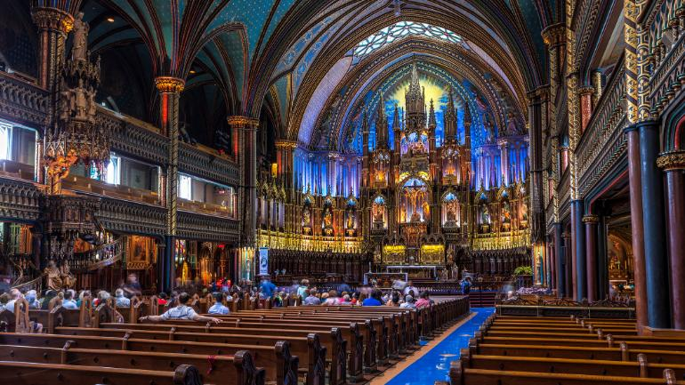Originally titled *Notre Dame de Paris* because the book is about the cathedral, not Quasimodo.

Hugo wrote the book because the cathedral was falling into disrepair. The book kickstarted the movement to preserve historic buildings.

“The book will kill the building.”

* *Hunchback* takes place right before the advent of the printing press.
* The rise of literacy diminishes the importance of visual art.
* Architecture is the writing of the illiterate—or as I like to say, building is the bookcraft of the unlettered.
* Sacred art (statuary, stained glass, etc.), like sacred music, serves a catechetical purpose.

# The quality triangle has 3 legs: good, fast, and cheap. You can have any 2, but not all 3.**They just don’t make cathedrals like they used to.**

No one knows who built Notre Dame, or any of the other great cathedrals—no one but God. No one is willing to be anonymous anymore; everyone wants credit.

We have neither the skill nor the patience. Discussions of rebuilding Notre Dame aimed to finish in 5 years. It took hundreds of years to build it in the first place.

When people were donating to Notre Dame, many objected that we ought to be giving to the poor instead because Jesus cares more about people than about stained glass.

* 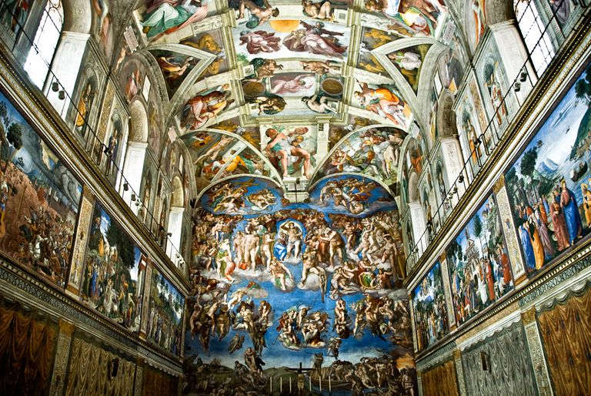Are the naysayers giving to the poor?
* The Catholic Church has done more for the poor than any other organization in history.
* Jesus doesn’t care about stained glass per se, but what stained glass does. If by looking at stained glass people learn about Him, He cares a great deal about it.

Some say disparagingly that cathedrals are like museums. That’s part of the point. Church wealth often comes from gifts from the faithful. Artists used to make priceless works of art for churches, where people of all social strata would see them. Now their art sits in museums—at best. Most often, it sits in the homes of those wealthy enough to buy it, and the only ones who see it are those whom the owners allow.

# **Giving God Our Best**

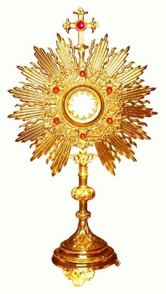Jesus was born in a stable, but the gifts of the magi (gold, frankincense, and myrrh) were among the most priceless items of the time.

The church is the house of God. Shouldn’t the King’s castle be magnificent? When we go to Mass, we go to Heaven. The space in which we celebrate Mass ought to reflect the majesty of Heaven.

Jesus in the form of bread and wine deserves monstrances and Eucharistic vessels made from precious metals.

In the Old Testament, God demanded the highest quality artwork and architecture for the Ark of the Covenant—from the nomadic Israelites. They had no gold mines; they had to work hard to produce goods to exchange for the materials.

# **Corruption among Renaissance Popes**

It is not uncommon for people to cite corrupt Renaissance campaigns to raise money, such as the sale of indulgences. The Medici and Borja families, both of which produced popes, went to great lengths to demonstrate their wealth and power. we have had popes who weren’t good at handling money, but assurance of infallibility in matters of faith and morals doesn’t guarantee impeccability. Sometimes we get the popes we deserve rather than the popes we need.